Brian Flores

CPE390

**Lab 3: Blink LED**

**Objective:**

To create a breadboard circuit with an LED and Resistor in series. Import code onto Arduino DUE to blink the LED.

**Code:**

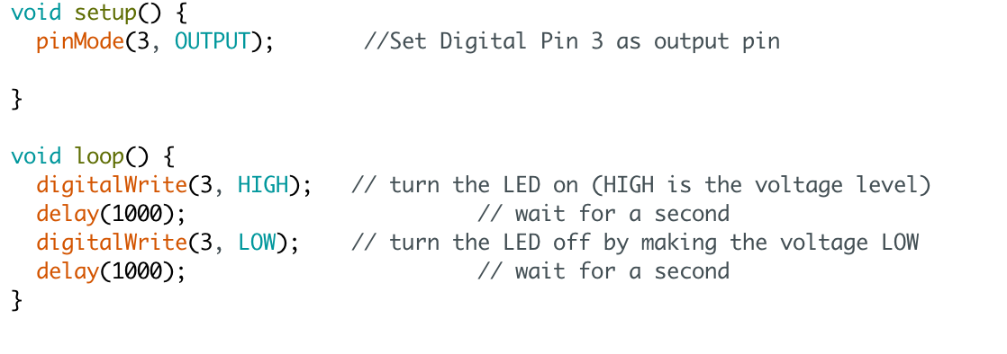

**Schematic:**

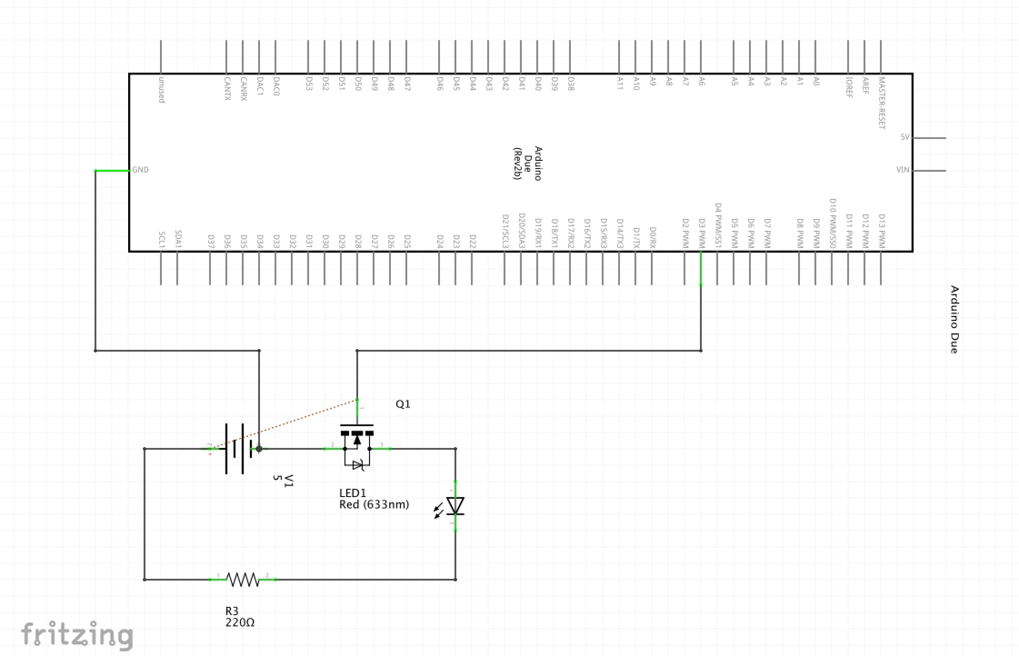

**Breadboard:**

